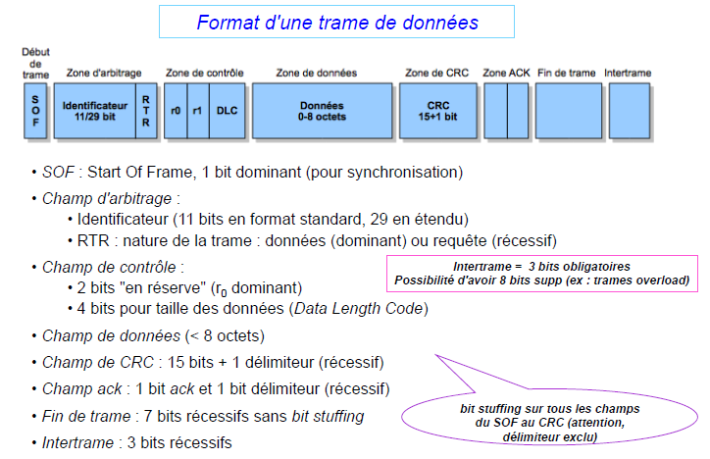

1 11 1 1 1 4 64 16 1 1 7 3 = 111bits max